**Leader Overview**

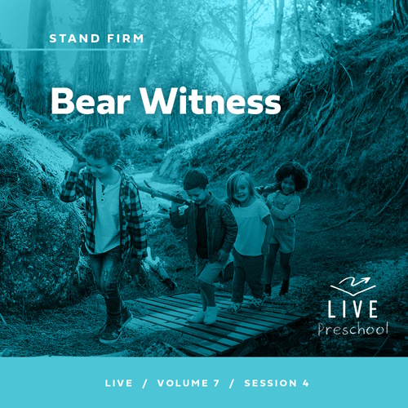

**Volume Overview**

**Stand Firm**

*The world thinks of power as action. Powerful people are able to take control, able to change things. But Jesus blessed the meek, the hungry, and the poor. There is a power this world overlooks. There is power in standing firm in faith. Christians have long stood their ground, not to gain this world’s power but as witnesses to a better world to come. So we stand strong, committed, and bear witness to the world.*

**Session Overview**

**Bear Witness**

*In this* **Live** *session, preschoolers will discover that they can stand up for Jesus regardless of what comes against them. They will explore the Bible story of Peter and John on trial after going to jail for healing a man who couldn’t walk. These two men decided to continue sharing the good news of Jesus despite threats from religious leaders. Preschoolers will begin to understand that God will help them stand firm in the face of difficulty, too.*

**Bible Lesson**

Peter and John Stand Trial

[Acts 4:1–21](https://ref.ly/logosref/Bible.Ac4.1-21)

**Faith Fact**

I will stand up for Jesus

**Faith Verse**

[Ephesians 6:13](https://ref.ly/logosref/Bible.Eph6.13) (NLT)

Put on every piece of God’s armor so you will be able to resist the enemy in the time of evil. Then after the battle you will be standing firm.

**Preparing for the Session**

**Leader Preparation Time: 20–25 Minutes**

|  |
| --- |
| ***You Will Need***  ***Preservice Activities***  *• Toys*  *• Hammer*  *• Piece of chalk or similar “hard” item to smash with hammer*  *• Paper plate to smash chalk on*  *• Optional: Paper towel for hands*  *• Stacking food (Cheese cubes, marshmallows, crackers, etc.)*  *• Small plates, one per kid*  ***Large Group***  *• Bible*  *• Worship songs (Song suggestions: “Movin’ Me” Lyric Video by Amber Sky Records; “Living Color” Lyric Video by Elevation Church Kids; “See a Victory” Lyric Video by Elevation Church Kids)*  *• For groups not using a phone or tablet only, add:*  *• Projector or TV*  *• Laptop*  *•* ***Faith Fact Sound*** *video (bell ringing)*  *•* ***Faith Fact Slide***  *•* ***Faith Verse Slide***  *•* ***Faith Verse Video***  *•* ***Bible Lesson Video A***  *•* ***Bible Lesson Video B***  **Small Group**  *• Paper plate, one per kid and the leader*  *• Copy paper*  *•* ***Small Group Activity Page****, one per kid*  *• Crayons or markers*  *• Wooden blocks, ten per group*  *• Bean bags or soft balls*  *• Floor-safe tape*  *• Balloons, two per group*  *• Empty 20 oz. bottle*  *• Vinegar*  *• Baking soda*  *• Permanent marker*  *• Liquid measuring cup*  *• Tablespoon for measuring*  *To access session content and videos from a computer, visit:* [***BibleEngagementProject.com/downloads***](https://bibleengagementproject.com/downloads) |
| ***Getting Ready***  ***Preservice Activities***  *• Set out toys and snacks.*  ***Large Group***  *• Download videos and slides if needed.*  *• Select worship song(s) and have them ready to play.*  ***Small Group***  *• Tear the copy paper into smaller pieces and wad it into balls.*  *• Print copies of the* ***Small Group Activity Page****, one per kid*  *• Tape two lines on the floor—one for the blocks to be stacked on and another for the kids to stand behind to throw from.*  *• Test this object lesson ahead of time. Ensure the vinegar and baking soda ratios will fill up the balloon you are using.*  *• Stretch a balloon by inflating it and then let the air out.*  *• Fill the balloon with 2 tablespoons of baking soda.*  *• Fill the bottle with 1/4 cup of vinegar.*  *• Optional: Write “I will stand up for Jesus.” on the balloon with the baking soda inside it.*  ***First time leading* Live *for Preschool? Check out the*** [**Facilitator Guide**](https://0b769b0ed3569ef9d18b-f88d8272f61086866d50d048b43ef630.ssl.cf2.rackcdn.com/sites/biblengagementproject/Listen_Facilitator_Guide.pdf)**.** |

**Preservice Activities**

*See what’s needed at the beginning of the session.*

**Bible Story Warm-Up**

I have a piece of chalk here. If I were to throw it at you, would it hurt if it hit you? *(Group response)* It’s hard, so it might. What if I took this piece of chalk and put it on a plate and then hit it with this hammer? Which one of these two things is harder: the chalk or the hammer? *(Group response)* That’s right, it’s the hammer.

Sometimes things seem pretty hard until you put them next to something else. What will happen if I hit the hammer with the chalk? *(Allow responses.)* How about if I hit the chalk with the hammer? *(Allow responses.)* Let’s find out.

• *Hit the hammer with the chalk first. Then smash the chalk with the hammer.*

The chalk seemed strong until I hit it with the hammer. When you have something stronger, the first thing doesn’t seem so hard anymore.

What are some other things that are hard and strong?

What are some things that are hard for you to do?

Who can help you with things that are hard?

From the Bible, we know that life won’t always be easy, but Jesus will be with us. We can overcome things that come our way because of Him. In Bible times, the people who knew Jesus the best faced a lot of hard times. Because they had seen Jesus do so many amazing things and spent time with Him, they knew the truth about who He was. In today’s Bible story, we’ll learn how two of Jesus’ followers never gave up on the things that they knew were true. You and I can do the same thing.

**Snack**

**Stand Up Snack (Cheese Cubes, Crackers, Large Marshmallows, etc.)**

I have a fun snack for you today. I want to see if you can stack up all the snacks I give you into a tower that will stand up on your plate. Let’s try it.

• *Hand out snack to kids along with a paper plate.*

• *After they have built their tower, kids may eat their snack.*

What was the hardest part of getting everything to stand up? *(Allow responses.)* Today, we’ll learn about a Bible story how standing up for Jesus can be very hard to do, but it’s not impossible.

**Free Play**

*Any extra time can be spent playing with toys.*

**Transition**

*A few minutes before service begins, have kids make their way to the large group area and sit in their designated areas.*

**Large Group**

**25 Minutes**

*See what’s needed at the beginning of the session.*

**Introduction**

Hi, everyone! It’s so wonderful to be here with you today. My name is _________. We’re in for an amazing day as we explore God’s Word, the Bible, together. *(Hold up the Bible.)* If you’re excited to be here, show me your happiest face. *(Group response)*

Your happy faces make me happy! This is my happy face *(demonstrate).* We’ll continue having more fun as we explore an amazing Bible story about two of Jesus’ disciples named Peter and John. They were put into jail even though they didn’t do anything wrong. Wait! Does that sound very happy? *(Group response)* No, but when we do what Jesus wants us to do, He gives us joy that grows even when we deal with unhappy things.

**Faith Fact**

Peter and John stood up for Jesus even when it was hard. Our Faith Fact today says we can choose to do that, too. Our Faith Fact is **I will stand up for Jesus.**

• *Show the* ***Faith Fact Slide.***

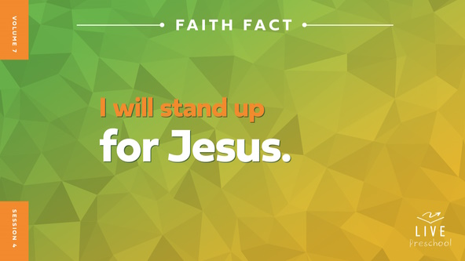

Let’s say our Faith Fact together. Let’s start by leaning far over to the right *(demonstrate).* Then as we say it, let’s stand up straight. **I will stand up for Jesus.** *(Group response)* Awesome! Let’s lean far over to the left and then stand up straight as we say it again. **I will stand up for Jesus**. Great job!

**Bible Time**

To stand up for Jesus, we need to know His truth, and we can learn that from a special Book. Does anyone know which Book teaches us God’s truth? *(Group response)* Yes! It’s the Bible. Let’s check in with Lizzy and see if she has a Bible story to share with us.

• *Play* ***Bible Lesson Video A****.*

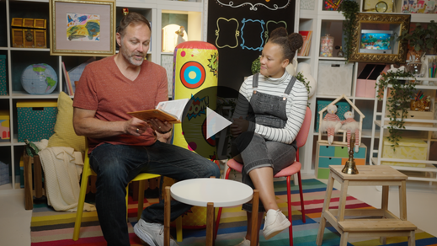

I’m so glad Lizzy gave us time to think about what happened next. Let’s worship God, and then I’ll ask you what you think Peter and John decided to do.

**Worship**

We can choose to show God how much we love Him through praise and worship. God is so good and loves us so much. He deserves all our praise. First, let’s tell Him how much we love Him.

**Praise**

Are you glad God loves you? Stretch your arms out wide, and then wrap yourself in a big hug. *(Group response)*

Are you thankful Jesus helps us to stand up strong? Sink low to the ground, and then let’s stand up strong! *(Group response)*

Who wants to thank God for joy even in unhappy times? Wave your hands up high. *(Group response)*

**Sing**

I love worshipping God with you! Another way we can do that is by singing. Let’s sing and tell God how great He is.

• *Lead the kids in singing one or two songs. See song suggestions at the beginning of the session.*

**Prayer**

Those songs remind us how much God loves us. Let’s pray and talk to God together.

|  |
| --- |
| *Dear God, we praise You. You are so strong, and You want to give us Your strength. Help us to share Your truth and love with those around us. Help us to stand up for You! Amen.* |

**Bible Time cont’d**

• *Start* ***Bible Lesson Video B*** *and pause on the image of the two choices.*

It’s almost time for Grandpa and Lizzy to come back! Let’s decide what you think happened next in our story. Should we put on our thinking caps? *(Demonstrate.)* What do you think? Did Peter and John stand up for Jesus and keep telling people about Him? *(Point to “Go light” graphic.)* Or did they stop telling people about Jesus? *(Point to “Stop” light graphic.)*

If you think Peter and John kept telling others about Jesus, tell the friend next to you, “The good news is about Jesus.” If you think Peter and John stopped talking about Jesus, don’t say anything and cover your mouth with your hands. Ready? Choose your answer.

• *Pause while kids respond.*

Let’s find out if you’re right! Let’s check back in with Lizzy and Grandpa.

• *Play* ***Bible Lesson Video B.***



Wow! Even though Peter and John could have been sent back to jail or something worse, they continued to tell others about Jesus. I’m so grateful we can tell anyone about Jesus. We may never have to worry about going to jail, but we might face times when it’s hard to stand up for Jesus. We can trust Him to help us if that happens.

**Response Time**

*Play a worship song quietly.*

Let’s respond to the truth that we learned today. Let’s stand up as we pray together.

• *Have the kids repeat phrases of the prayer after you.*

|  |
| --- |
| *Dear Jesus, I want to stand for You and Your truth. Please give me Your strength so I can tell others about You. Speak to me through Your Holy Spirit to give me Your words. Amen.* |

**Faith Verse**

I love praying with you, friends. I believe God is going to use you to tell others about Him as you stand strong. Learning Bible verses helps us to stand for Jesus. Let’s say our Faith Verse and do the actions together.

[Ephesians 6:13](https://ref.ly/logosref/Bible.Eph6.13) (NLT)

Put on every piece of God’s armor so you will be able to resist the enemy in the time of evil. Then after the battle you will be standing firm.

• *Show the* ***Faith Verse Video****.*



**Ephesians** *(hands at waist, spread apart, palms up and out)*

**6:** *(hands together like a clap)*

**13** *(hands opened to “book”)*

**Put on every piece** *(bring one arm crosswise to pat opposite arm and repeat with other arm)*

**of God’s armor** *(pretend to put on helmet)*

**so you will be able to resist** *(cross forearms together in front)*

**the enemy in the time of evil.** *(put arms out like showing strong biceps)*

**Then after the battle** *(turn around)*

**you will still be standing firm.** *(jump and land with feet together)*

**Closing**

Who wants to share one thing you learned today? *(Allow responses.)* You all have listened so well to learn from God’s Word. Peter and John gave us a great example of how to stand up for Jesus even if people don’t like what we’re saying about Him. You know who else can stand up for Jesus?

• *Play the* ***Faith Fact Sound*** *video (bell ringing).*

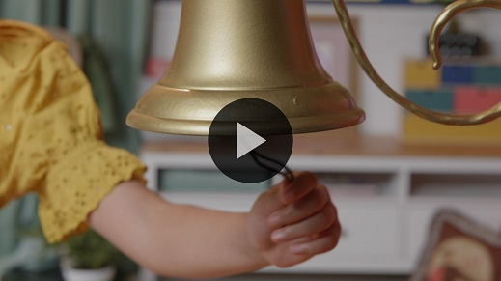

The answer to that question is in our Faith Fact. Let’s say it one more time. **I will stand up for Jesus**.

• *Show the* ***Faith Fact Slide.***



Let’s start as low as we can go *(crouch down low)* and say our Faith Fact quietly. **I will stand up for Jesus**. Let’s stand halfway up and say it in a medium voice. **I will stand up for Jesus.** Stand as tall as you can and say our Faith Fact one last time as loudly as you can. **I will stand up for Jesus.**

**Dismissal to Small Groups**

Great job! You have some great fun ahead of you as we dismiss you to go with your small groups.

• *Dismiss the kids by groups.*

|  |
| --- |
| ***Leader Tip:*** *This can be done by assigning color teams or by age groups. Note that some young preschoolers may not know their age. Using a colored sticker, jersey, or wristband will help separate the kids and help identify their small groups.* |

**Small Group**

**25 Minutes**

*See supplies and prep instructions at beginning of session or in each activity below.*

|  |
| --- |
| ***Leader Tip:*** *Small groups can alternate to each circle, or all groups can do each activity at the same time. If you choose to alternate, you will need at least one leader per circle*. |

**Circle 1**

**Group Connection**

**Ready for Battle**

|  |
| --- |
| ***You Will Need***  *• Paper plate, one per kid and the leader*  *• Copy paper*  ***Getting Ready***  *• Tear the copy paper into smaller pieces and wad it into balls*. |

Today, we have a super fun game to play. It’ll require a little bit of imagination and some good defensive skills. We’ve been learning a Bible verse that teaches us how God has prepared us for every attack from the enemy. God has given us His armor so that we can stand firm. Let’s take a moment and say our Faith Verse together.

• *Lead kids through the Faith Verse.*

[Ephesians 6:13](https://ref.ly/logosref/Bible.Eph6.13) (NLT)

Put on every piece of God’s armor so you will be able to resist the enemy in the time of evil. Then after the battle you will still be standing firm.

Our Faith Verse talks about God’s armor. In the Bible, God says that our faith in Him is like a shield.

• *Give each kid a paper plate.*

• *Hold up some paper balls.*

This plate is your shield. You will use your paper plate to keep these paper balls from hitting you. I’ll show you how we’ll play. I’ll throw a paper ball at you. Use your shield to keep it from hitting you.

• *Throw a paper ball at each kid.*

Now it’s your turn. If there’s a paper ball near you, you can pick it up and throw at back at me.

• *Pick up a plate shield and let kids throw the paper balls at you. Have fun with this.*

Now, it’s time that we all play. When a paper ball lands near you, pick it up and throw it at someone else. Remember to only throw at someone’s body not the face. When you hear me say, “Ready for battle,” everyone must freeze, and we’ll say our Faith Verse together. Who is ready to play? *(Group response)*

• *Remember to call out, “Ready for battle,” multiple times during the game time.*

• *Allow them to play for as long as time permits.*

That was fun! You are definitely ready for battle!

**Circle 2**

**Activity Page Time**

**Peter and John Stand Strong**

|  |
| --- |
| ***You Will Need***  *•* ***Small Group Activity Page****, one per kid*  *• Crayons or markers*  ***Getting Ready***  *• Print copies of the* ***Small Group Activity Page****, one per kid.* |

Who can tell me the names of the men in our Bible story today? *(Allow responses.)* That’s right! We learned about Peter and John. They were doing a great job of telling others about Jesus. Was everyone happy that they were talking about Jesus? *(Group response)* No, not everybody wanted them to tell people that Jesus loved them. Some leaders started getting mad, and Peter and John found themselves in jail. They never gave up or quit. Instead, they stood up for Jesus. Everyone was amazed.

• *Hand out a copy of the* ***Small Group Activity Page*** *and crayons to each kid.*

On your Activity Page, you’ll see a drawing of Peter and John standing in front of a crowd. It didn’t matter what happened to them before or after they were arrested. They never stopped standing up for Jesus and for what was right. God wants us to stand up for Jesus, too. That doesn’t mean we’ll end up in jail one day, but it does mean there may be people who won’t want us to tell others that Jesus loves them. We choose to do the right thing because we love Him. We want to show Jesus and others how much He means to us.

I want you to take your time as you color your paper today. When you’re done, I want you to stand up and say today’s Faith Fact: **I will stand up for Jesus**.

• *Allow time for the kids to color their* ***Small Group Activity Page****.*

• *During the activity, interrupt and practice the Faith Fact:* **I will stand up for Jesus.**

• *Play the* ***Faith Fact Sound*** *video. Review the Faith Fact even if you can’t play the sound.*



Your pictures look amazing! One thing I know for sure is I want to stand up for Jesus! If you want to stand for Jesus, say, “Count me in!” *(Group response)* All right! Before we move on, let’s say our Faith Fact together. Ready? **I will stand up for Jesus.**

**Circle 3**

**Feet-to-Floor Game Time**

**Get Up Again**

|  |
| --- |
| ***You Will Need***  *• Wooden blocks, ten per group*  *• Bean bags or soft balls*  *• Floor-safe tape*  ***Getting Ready***  *• Tape two lines on the floor—one for the blocks to be stacked on and another for the kids to stand behind to throw from.* |

Our game requires some things to get knocked down. While knocking things down is always fun, we will stand the blocks back up because we always want to stand up for Jesus. Who is ready to play a fun game? *(Group response)* Great! I’m glad everyone loves playing games as much as I do.

In our Bible story, we learned that Peter and John ended up in a pretty rough spot. Some people tried to knock them down by putting them in jail. Peter and John never quit standing up for Jesus even when things got hard. Today, you’ll help Peter and John stand back up if they get knocked down. First, we need to make two block towers.

• *Make two stacks of the wooden blocks, five blocks in each stack, on one of the lines.*

As you can see, we made two block towers—one for Peter and one John. We’ll make two teams with each team standing in a line. One team will represent Peter and John. The other team will be the men on the council who tried to get them in trouble. First, the men on the council will take turns trying to knock down the towers. If they knock down a tower, the first person on Peter and John’s team will run over and stand it back up. As soon as you’re done standing up the blocks into a tower, I want you to say our Faith Fact as loud as you can. When everyone on the bad guys’ team has had a chance to knock down Peter and John, we’ll switch sides.

Before we start, let’s say our Faith Fact together. Ready? **I will stand up for Jesus.**

• *Help the kids line up in two separate lines.*

• *Allow them to take turns throwing the bean bags. Make sure that no one is throwing while another kid is stacking up a tower.*

• *Play for as long as time permits.*

That was awesome! No matter what happens in life to knock us down, we can get right back up again. Before we move on, let’s say our Faith Fact together one more time. **I will stand up for Jesus.**

**Circle 4**

**Hands-On Learning**

**Stand Up Balloon Object Lesson**

|  |
| --- |
| ***You Will Need***  *• Balloons, two per group*  *• Empty 20 oz. bottle*  *• Vinegar*  *• Baking soda*  *• Permanent marker*  *• Liquid measuring cup*  *• Tablespoon for measuring*  ***Getting Ready***  *• Test this object lesson ahead of time. Ensure the vinegar and baking soda ratios will fill up the balloon you are using.*  *• Stretch a balloon by inflating it and then let the air out.*  *• Fill the balloon with 2 tablespoons of baking soda.*  *• Pour ¼ cup of vinegar into the empty bottle.*  *• Optional: Write “I will stand up for Jesus.” on the balloon with the baking soda inside it.* |

Peter and John stood up for what was right. When they did that, everybody saw how bold they were and how strong their faith in God was. Standing up for Jesus shows people how much He means to us. It would be easy if you could do it quietly or secretively. You can’t stand up for Jesus without other people noticing.

• *Hold up the empty balloon.*

Has anybody ever tried to blow up a balloon? *(Group response)* Sometimes when a balloon is brand-new, it can be really hard to blow up. If I just wave this balloon around in the air, will it blow up? *(Group response)* No, it won’t work. What if I stick it in my pocket? *(Group response)* Nope!

• *Place the first balloon in your pocket.*

• *Grab the baking soda-filled balloon.*

Now, watch what happens when we put the balloon right here for everyone to see.

• *Carefully attach the balloon to the mouth of the bottle without holding the balloon upright.*

• *Have kids count you down from three before lifting up the balloon.*

• *When you lift the balloon, be sure to hold it tightly so it doesn’t come off the bottle.*

Whoa! That balloon is standing straight up on top of the bottle for everyone to see! Just as awesome as it is to see the balloon stand up, it’s even more awesome to see you stand up for Jesus and tell others how much He loves them.

**Dismissal**

• *Play the* ***Faith Fact Sound*** *video (bell ringing).*



• *Show the* ***Faith Fact Slide.***



I know sometimes standing up for the right thing can be hard, but the good news is we never have to do it on our own. Jesus is always with us, and that’s what we’ve been learning about today. I love that I get to come learn with all of you. I can’t believe our time is almost gone. Before we leave, can we say our Faith Fact together one more time? *(Group response)* **I will stand up for Jesus.** Amazing! I had a great time learning more about God’s Word with you. See you next time!

• *Send home the* ***Small Group Activity Page*** *with each kid.*

• *Remind parents that there are* ***Family Devotions*** *available on the app to do with their kid.*

• *Tell everyone the date and time for the next session.*